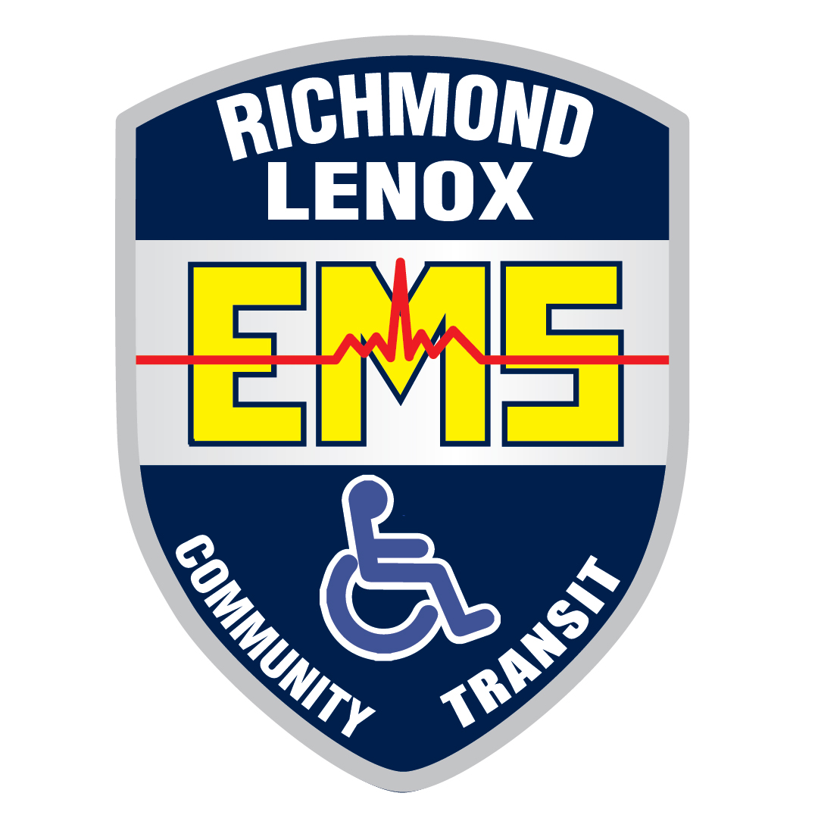
LENOX / NEW HAVEN / CHESTERFIELD SHUTTLE

Richmond Lenox E.M.S. in partnership with SMART provides daily shuttle service from New Haven to 23 Mile Rd & Gratiot. Passengers may board at one of the many stops listed below. Passengers can transfer to SMART Route 560 at Gratiot & 23 Mile Road.

M-19 & Potter (City offices)  City of Memphis | X | X | 7:15 AM |  | N/A | 3:05 PM | N/A
Main & Oak (RR Tracks)  City of Richmond | X | X | 7:35 AM |  | N/A | 3:15 PM | N/A
Meijer 26/I-94 | X | 5:55 AM | 8:03 AM |  | 1:50 PM | 3:35 PM | 4:53 PM
QUAIL RUN | X | 6:00 AM | 8:08 AM |  | 1:55 PM | 3:45 PM | 4:58 PM
NORTH VILLAGE MARKET | 5:02 AM | 6:10 AM | 8:18 AM |  | 2:05 PM | 3:49 PM | 5:00 PM
BRAMBLEWOOD | 5:06 AM | 6:14 AM | 8:22 AM |  | 2:07 PM | 3:53 PM | 5:02 PM
PINEWOOD | 5:10 AM | 6:18 AM | 8:26 AM |  | 2:09 PM | 4:00 PM | 5:05 PM
HAVENRIDGE & DIVISION | 5:14 AM | 6:22 AM | 8:30 AM |  | 2:13 PM | 4:04 PM | 5:08 PM
NEW HAVEN & GRATIOT | 5:17 AM | 6:26 AM | 8:34 AM |  | 2:17 PM | 4:08 PM | 5:11 PM
GRATIOT & 24 MILE | 5:22 AM | 6:30 AM | 8:41 AM |  | 2:21 PM | 4:18 PM | 5:17 PM
GRATIOT & CARRIAGEWAY | 5:26 AM | 6:33 AM | 8:45 AM |  | 2:28 PM | 4:22 PM | 5:20 PM
Arrival at Meijer's | 5:32 AM | 6:59 AM | 8:50 AM |  | 2:31 PM | 4:30 PM | 5:30 PM
WENDY’S | 5:35 AM | 7:03 AM | 8:55 AM |  | 2:35 PM | 4:34 PM | 5:34 PM

MONDAY THRU FRIDAY SHUTTLE TIMES

SATURDAYS BY APPOINTMENT ONLY
Please call 586-749-7713 or toll free 844-666-5652

How much does it cost:
Base Fare $2.00
Seniors & Special Needs $1.00
Transfers to SMART FREE

Additional Richmond Lenox E.M.S. service
Contact Richmond Lenox E.M.S. for other transportation needs in New Haven, Lenox, Ray, Chesterfield, New Baltimore, Richmond, Memphis and the Armada area at (586) 749-7713.
Additional SMART service.
For more information about SMART’s fixed route or curb-to-curb Connector service please call (866) 962-5515 or visit www.smartbus.org.

